
Your trusted source for independent sensor data Photons to Photos Last revised: 2009-02-28
Previous Article Table of Contents Next Article

Sensor Analysis Primer - Photon Transfer Curve
By Bill Claff

Introduction
The Photon Transfer Curve (PTC) is the single most useful characterization of sensor performance.
The standard Photon Transfer Curve is a log₁₀-log₁₀ curve of noise in electrons versus signal in electrons.
Because we are interested in photography rather than engineering, we will use log₂ rather than log₁₀ throughout this article.
You can gather your own data and construct Photon Transfer Curves using the NefUtil program available at my web site.
Refer to the NefUtil documentation for details on the +CPTC option.

Standard Photon Transfer Curve - Single ISO in ADUs
Here is a chart of Photon Transfer Curve for the Nikon D300 in ADUs at ISO 200 based on 14-bit ADUs:
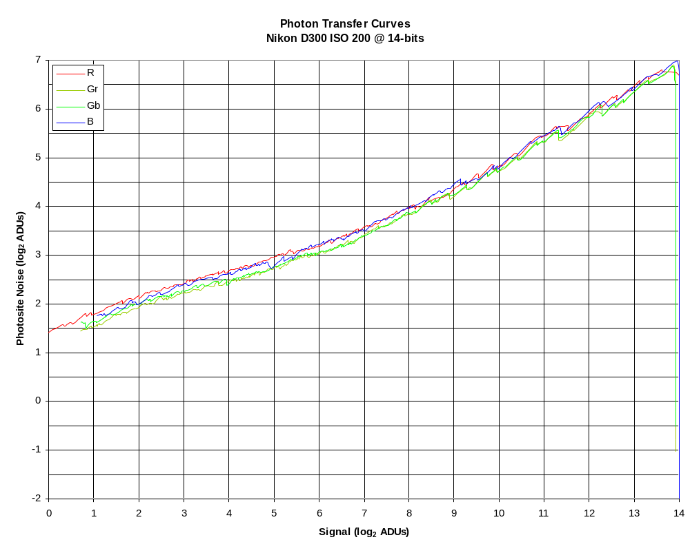
Each of the four Color Filter Array (CFA) channels is shown separately.
As expected, the four CFA channels are close together.
As the sensor saturates (clips), noise drops sharply to zero; however this is expected.
For clarity, and since the CFA channels are quite close together, the Gr channel will be used for the balance of this article.

Standard Photon Transfer Curve – Multiple ISOs in ADUs
Here is a chart of Photon Transfer Curve for the Nikon D300 in ADUs at all whole ISOs based on 14-bit ADUs:
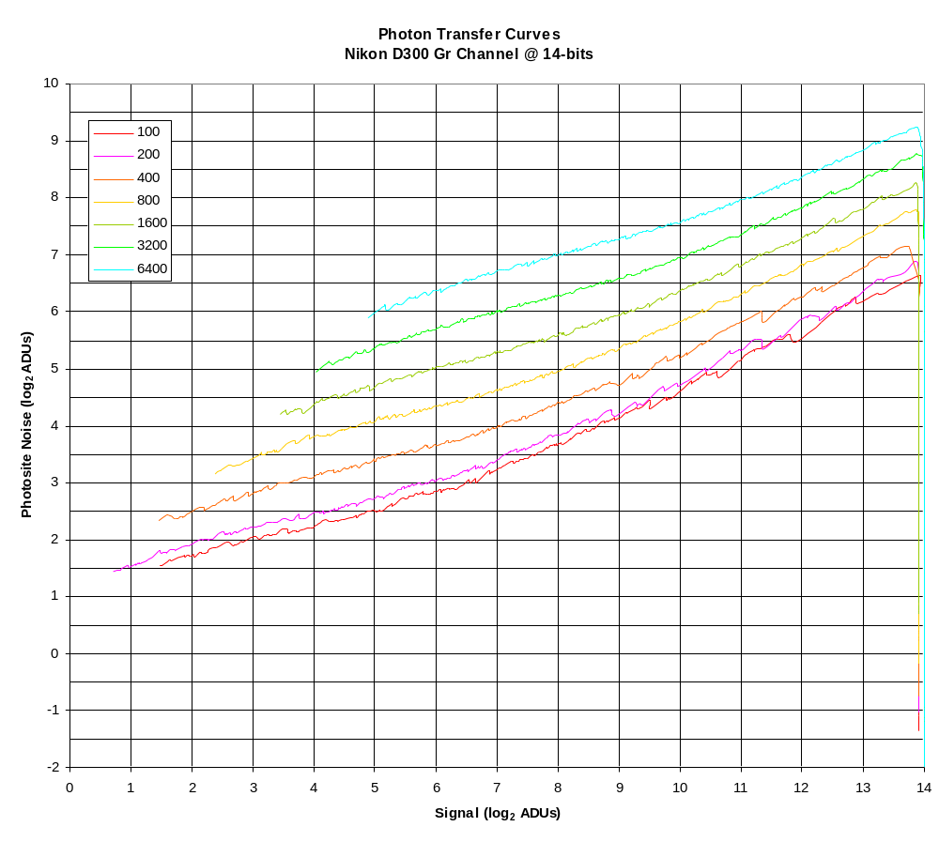
As expected noise in ADUs increases as ISO increases.

Standard Photon Transfer Curve – Multiple ISOs in electrons
Here is a chart of Photon Transfer Curve for the Nikon D300 in electrons at all whole ISOs based on 14-bit ADUs:
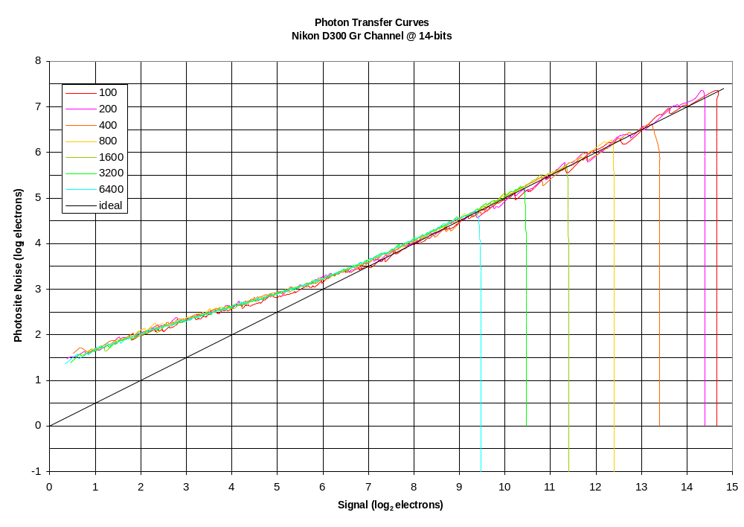
In terms of electrons, all of the different ISO values essentially lie on top of each other, and what really changes is the saturation point.
Only at the lowest (native) ISO is the Full Well Capacity (FWC) of the sensor used.
At ISO values higher than the native sensitivity, the increased gain causes the sensor to clip before FWC is reached.
The black line labeled “ideal” shows the performance of a perfect sensor that would only be affected by Photon Noise.
Note that the “ideal” line has a slope of ½ because Photon Noise is the square root of the signal.

Conclusions
Examination of the Photon Transfer Curve in electrons shows that the primary performance penalty for increasing ISO above the native ISO is unused Full Well Capacity resulting in lost dynamic range.

